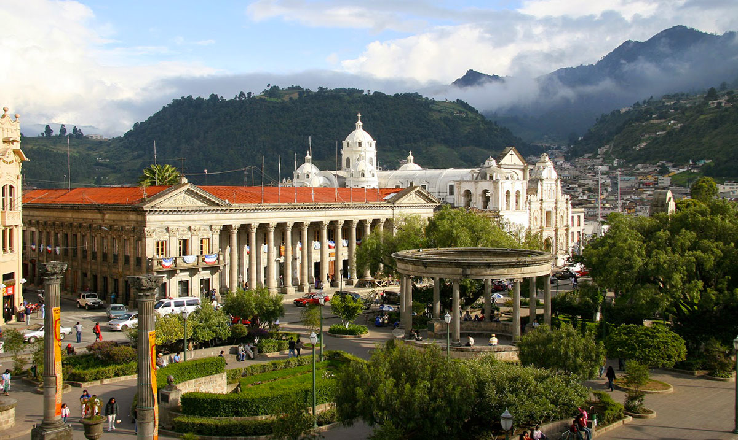

**SPA 206/302: Block 4, 2018. Spanish Abroad: Human Rights and the Quest for Justice in Guatemala**

**Professor**: Michael Mosier

**Email**: [mmosier@cornellcollege.edu](mailto:mochoa-shivapour@cornellcollege.edu)

**Location**: SISAI School in Xela (Quetzaltenango), Guatemala

**Course Description:**

This combined 206/302 course will consist of intermediate/advanced Spanish language practice with a focus on Guatemalan culture and human rights issues. Through intensive language practice we will analyze the tumultuous quest for justice - especially amongst the Mayan population - that has characterized this Central American nation since its founding. Students will stay with host families in Xela and meet for class at the SISAI School. In addition to this, students will participate in film nights, dance lessons, cooking lessons, and other activities.

**Educational Outcomes:**

SPA 206/302 supports the educational priorities and outcomes of Cornell College with emphasis on intercultural literacy, communication, knowledge, inquiry, and reasoning.

**Grading:**

Days will be split between a language/cultural component and a reading/discussion component. In the language classes, you will be evaluated through homework exercises, quizzes, and exams. In the discussion classes with Professor Mosier, you will write three reflections and one short essay reflecting on our readings and human rights in Guatemala. SPA 302 students will complete an additional assignment.

**Attendance:** Plan to arrive on time each day. Students are expected to speak in Spanish only. After one unexcused absence, your final grade will be lowered 3% for each additional absence.

**Academic honesty:**

**No plagiarism.. Cornell College’s official policy:**

**http://www.cornellcollege.edu/student-affairs/compass/academic-policies.shtml#f**

**Accommodations for All Students**:

Cornell College is committed to providing equal educational opportunities to all students.  If you have a documented learning disability and will need any accommodation in this course, you must request the accommodation(s) from the instructor of the course as early as possible, and no later than the third day of the term.  Additional information about the policies and procedures for accommodation of learning disabilities is available on the Cornell web site at:  
<http://www.cornellcollege.edu/academic_affairs/disabilities/>

**Course Goals:**

Students will improve speaking, writing, and listening skills through a total Spanish immersion experience.

Students will become acquainted with important aspects of Guatemala’s history and culture.

|  |  |  |  |  |  |
| --- | --- | --- | --- | --- | --- |
| **Lunes 26** | **Martes 27** | **Miércoles 28** | **Jueves 29** | **Viernes 30** | **Sábado 1** |
|  | **Arrive to Guatemala City at 1:25 p.m.**  **Shuttle to Xela**  **Intro to school and host families** | **Clases de Español**  At SISAI school  **3:30-5:00. The Maya**  **(Breaking the Maya Code) [w/Michael]**  **Clase de baile (Salsa y bachata) 5:00 p.m.** | **Clases de Español**  **3:30-5:00. Coffee, Bananas, and Human Rights (coffee and banana readings) [w/Michael]** | **Clases de Español**  **Noche de Trivia**  **7:30** | **LIBRE** |
| **Lunes 3** | **Martes 4** | **Miércoles 5** | **Jueves 6** | **Viernes 7** | **Sábado 8** |
| **Clases de Español**  **Película: Bajo la misma luna**  **3:00** | **Clases de Español**    **3:30-5:00. Xela and the K’iche’ (Grandin Readings) [w/Michael]**  **5:00: Clase de cocina** | **Clases de Español**    **3:00.Tejido, Baile, y Chocolate** | **Clases de Español**  **3:30-5:00. Rigoberta Menchú [w/Michael]** | **Clases de Español**  **7:30. Fiesta y noche de canciones** | **LIBRE** |
| **Lunes 10** | **Martes 11** | **Miércoles 12** | **Jueves 13** | **Viernes 14** | **Sábado 15** |
| **Clases de Español**  **3:00. “Cosmovisión Maya”** | **Clases de Español**  **4:00. Clase de baile** | **Clases de Español**  **3:30-5:00. Truth and Human Rights in Guatemala (Sanford Readings) [w/Michael]** | **Clases de Español**  **6:00. Necro Tour** | **Clases de Español**  **3:00. Fiesta de Navidad con los niños** | **LIBRE** |
| **Lunes 17** |  |  |  |  |  |
| **Clases de Español**  **3:30-5:00. Discussion of Jimmy Morales articles [w/Michael]** | **Clases de Español** | **Shuttle to airport**  **Guatemala—Atlanta 2:34 p.m.** |  |  |  |